Order Of Service

Singing: Psalm 32—CW page 78

Reading: Psalm 119:89-96

Opening Hymn: TLH 631

Reading: I Peter 1:13-25

Request Hymn: CW Supplement 752

Reading: Luke 12:1-7

Sermon Hymn: TLH 238

Sermon Text: Acts 19:11-22

Burning The Books

Prayer

The Apostles’ Creed, TLH page 12

Holy Communion

The Lord's Prayer

The Blessing

Closing Hymn: TLH 50

************

Bible Study: Lambs: The Dead Sea
Sheep: Deut. 20:1-20
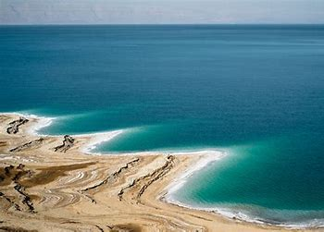

The Dead Sea

Water
Of
Life
25 May 2025

W A T E R O F L I F E

Independent Christian Church—Conservative Lutheran Doctrine

Worship Service: 9:30 a.m.

Larry Cooper, Pastor E-Mail address:
lcooper@wateroflife.cc
Web Site:
www.wateroflife.cc

* * * * * * * * * * * * * * * * * * * * * * * * * * *

Sermon Text: Acts 19:11-21

Burning The Books

* * * * * * * * * * * * * * * * * * * * * * * * * * *

11 And God wrought special miracles by the hands of Paul:
12 So that from his body were brought unto the sick handkerchiefs or aprons, and the diseases departed from them, and the evil spirits went outof them.\
13 Then certain of the vagabond Jews, exorcists, took upon them to call over them which had evil spirits the name of the Lord Jesus, saying, We adjure you by Jesus whom Paul preacheth.
14 And there were seven sons of one Sceva, a Jew, and chief of the priests, which did so.
15 And the evil spirit answered and said, Jesus I know, and Paul I know; but who are ye?
16 And the man in whom the evil spirit was leaped on them, and overcame them, and prevailed against them, so that they fled out of that house naked and wounded.
17 And this was known to all the Jews and Greeks also dwelling at Ephesus; and fear fell on them all, and the name of the Lord Jesus was magnified.
18 And many that believed came, and confessed, and shewed their deeds.
19 Many of them also which used curious arts brought their books together, and burned them before all men: and they counted the price of them, and found it fifty thousand pieces of silver.
20 So mightily grew the word of God and prevailed.
21 After these things were ended, Paul purposed in the spirit, when he had passed through Macedonia and Achaia, to go to Jerusalem, saying, After I have been there, I must also see Rome.

